Windows AD Lab
Purpose:
This Lab will give me hands-on experience with Windows Server Administration by deploying and configuring an Active Directory Doman service Environment. This project will give me experience using technologies which include organizational units, security groups, group policy objects, and role-based access control. This will simulate a small business network centralizing management of users, devices, and security settings. This Lab will demonstrate administration concepts commonly used in SOC environment.

Lab environment:
What I Did
I created a Windows Server virtual machine using VirtualBox and configured the resources needed to run the server. After several installation issues and troubleshooting steps, I successfully installed Windows Server and prepared it for Active Directory deployment.
What I Learned
I learned how virtualization allows IT professionals to build and test environments without needing additional physical hardware. I also learned that proper system configuration is important because even small setup mistakes can prevent a server from installing correctly.
Screenshots

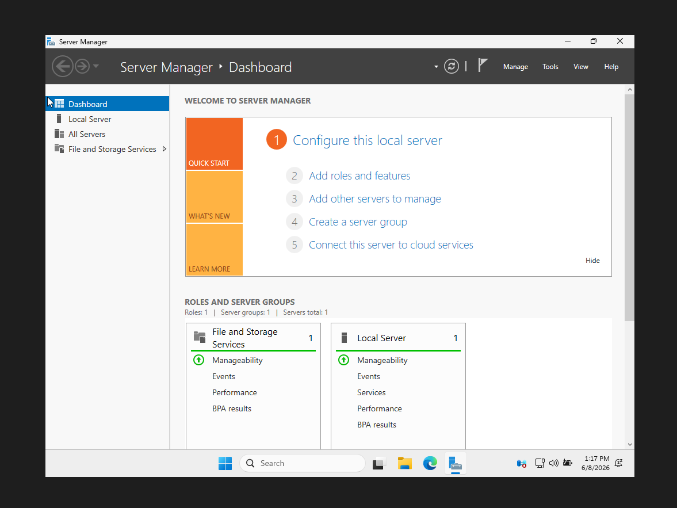
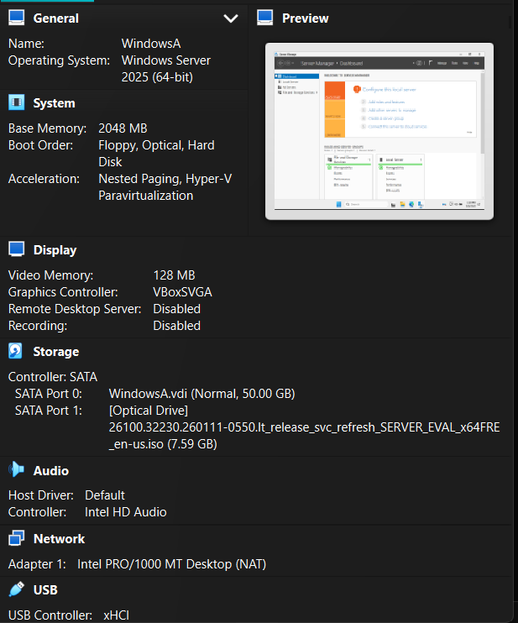

Active Directory Installation:
What I Did
I installed the Active Directory Domain Services role and promoted the server to a Domain Controller. During the setup process, I created a new forest named abc.local and configured DNS to support the domain.
What I Learned
Before this lab, I had heard the terms Active Directory, DNS, and forest, but I didn't fully understand how they worked together. I learned that Active Directory acts as the central system for managing users and devices, while DNS helps computers locate services within the domain. I also learned that a forest is the top-level structure that contains everything within the Active Directory environment.
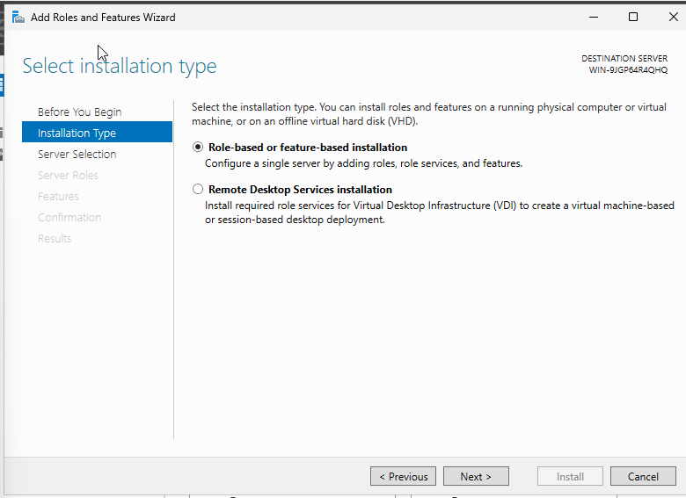
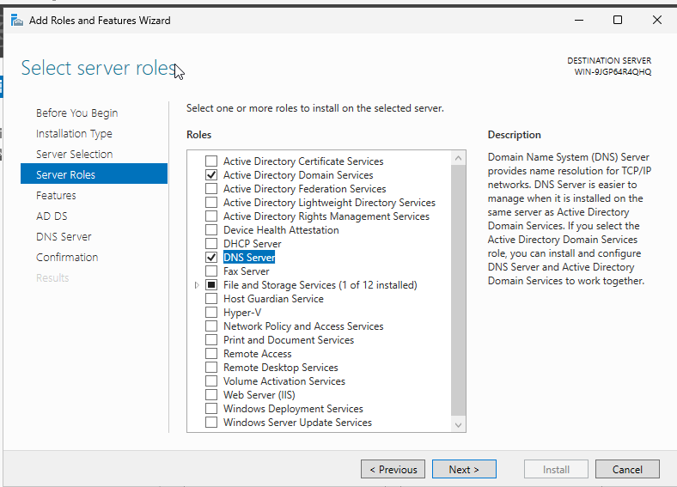

Organizational Unit Structure:
What I Did
I created Organizational Units for different departments including IT, HR, Finance, Sales, and Workstations. These OUs were used to organize resources within the domain.
What I Learned
I learned that OUs make it easier to organize users and devices based on departments or job functions. I also learned that OUs can be used to apply specific policies to certain groups of users without affecting everyone in the organization.

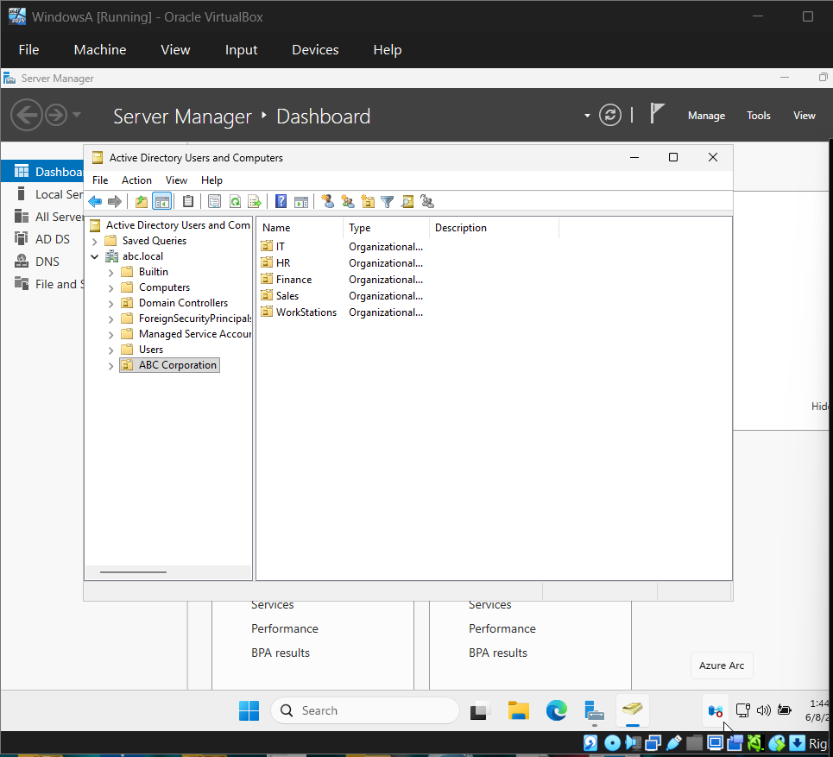

Users and Group Management:
What I Did

I created user accounts for employees in different departments and created security groups for each department. After creating the groups, I assigned users to the appropriate group based on their role.

What I Learned

I learned how organizations use security groups to simplify user management. Instead of assigning permissions to each individual user, permissions can be assigned to a group and automatically inherited by everyone who belongs to that group.
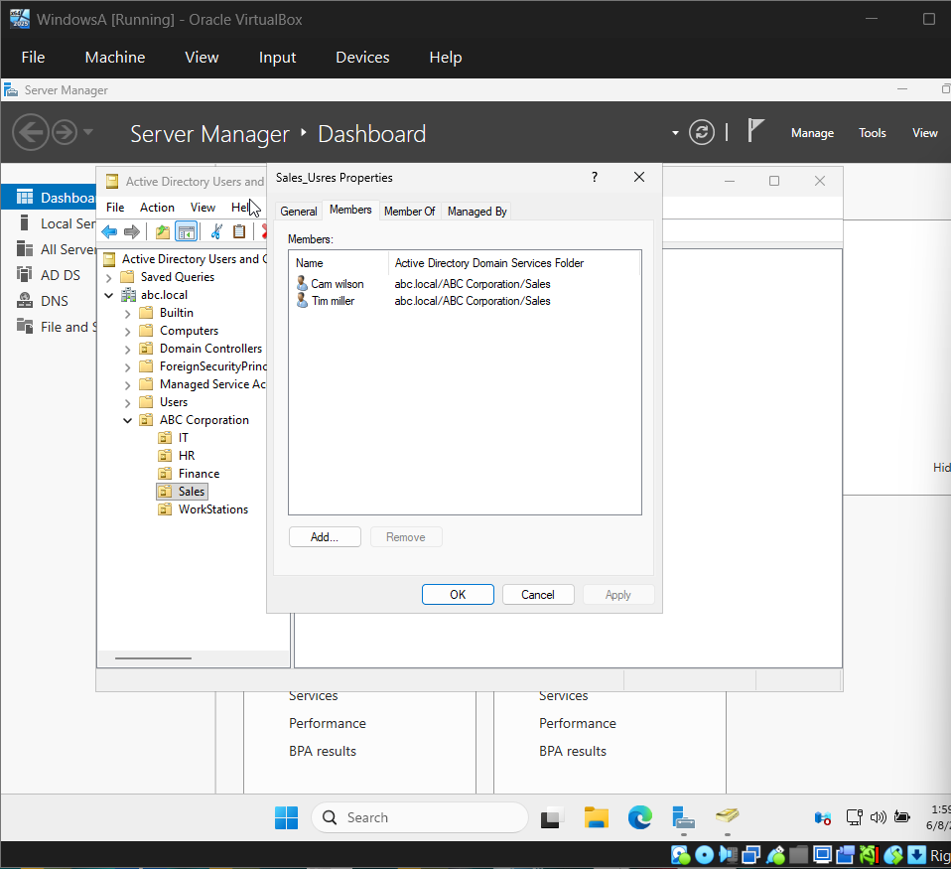
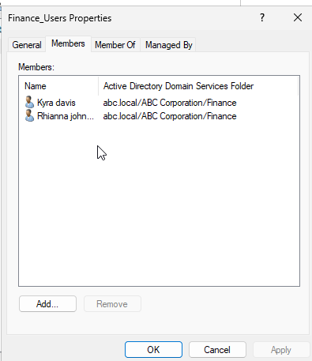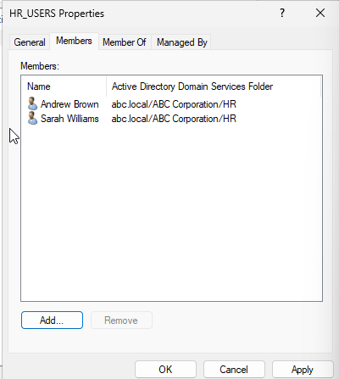
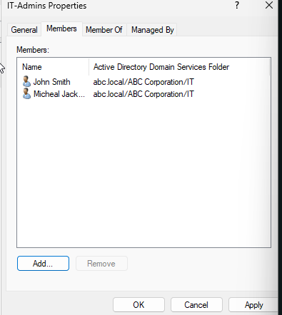

Shared Resources and Permissions:

What I Did

I created shared folders for each department and configured permissions so users could only access resources that matched their role. Permissions were assigned through security groups rather than directly to individual users.

What I Learned

I learned how permissions help protect sensitive information by limiting access to authorized users. I also learned the concept of Role-Based Access Control (RBAC), which is commonly used in enterprise environments to manage access more efficiently.
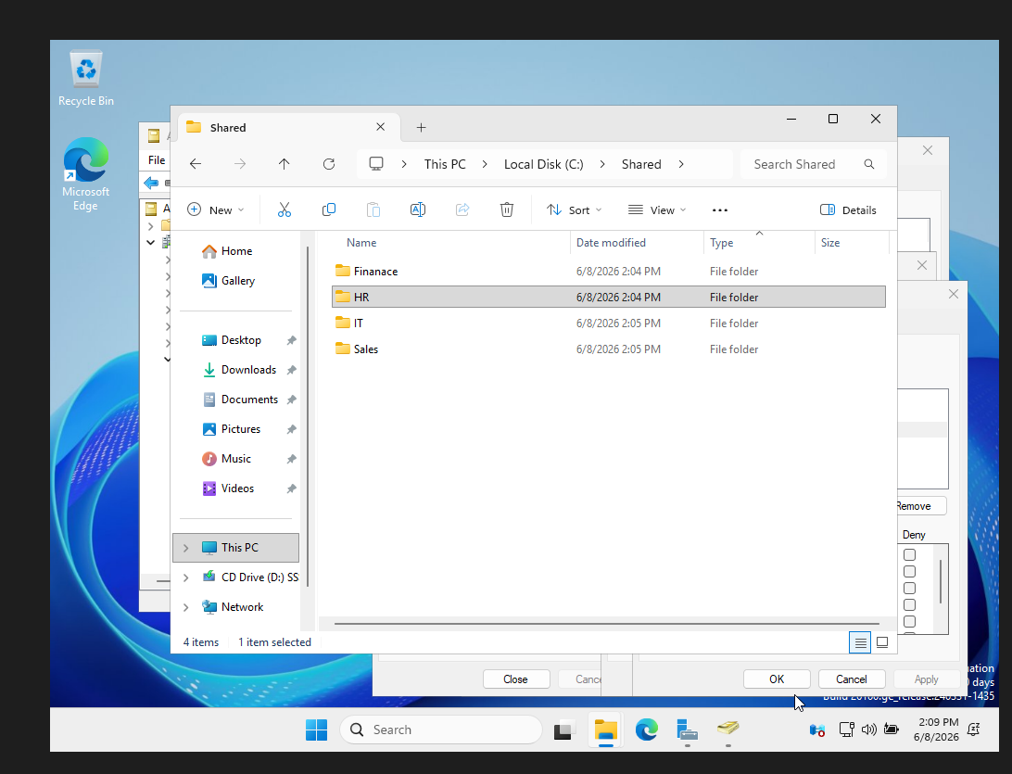
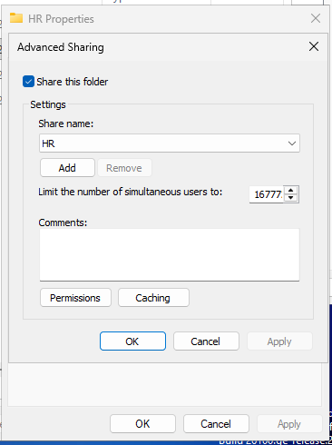
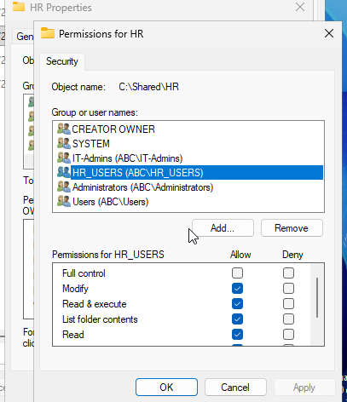
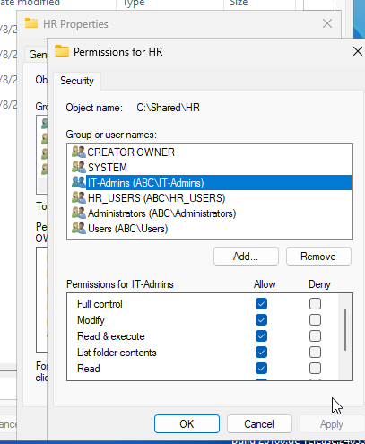

Group policy objects:
What I Did

I configured Group Policy settings to strengthen security across the environment. These policies included password requirements, account lockout settings, and workstation security controls.

What I Learned

I learned how administrators can use Group Policy to manage security settings from a central location instead of configuring each computer individually. This showed me how organizations maintain consistent security standards across their networks.
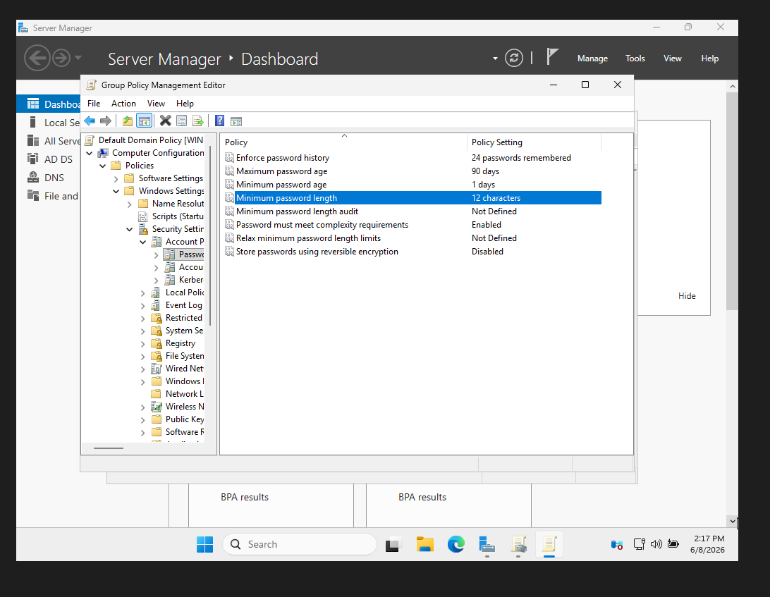
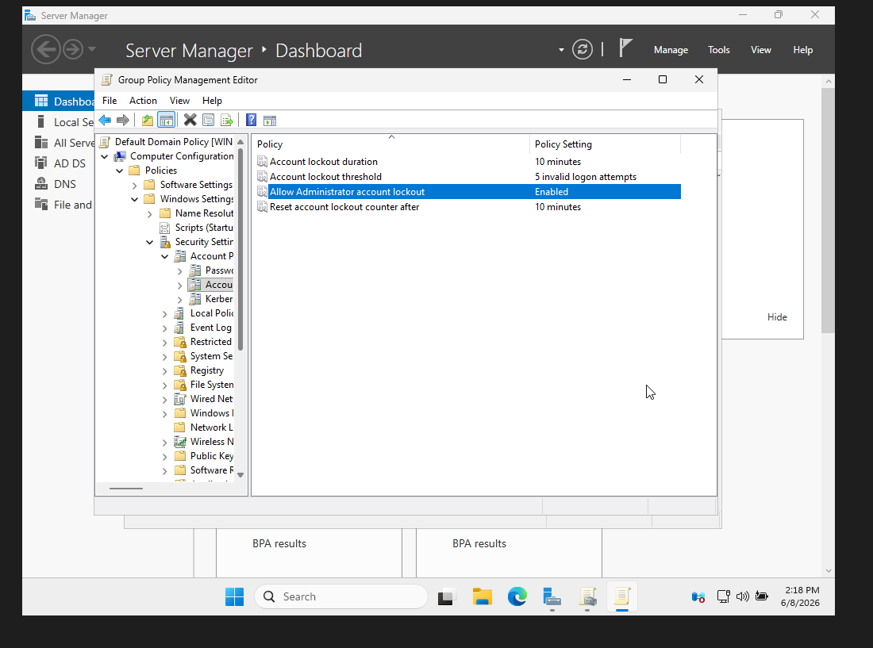
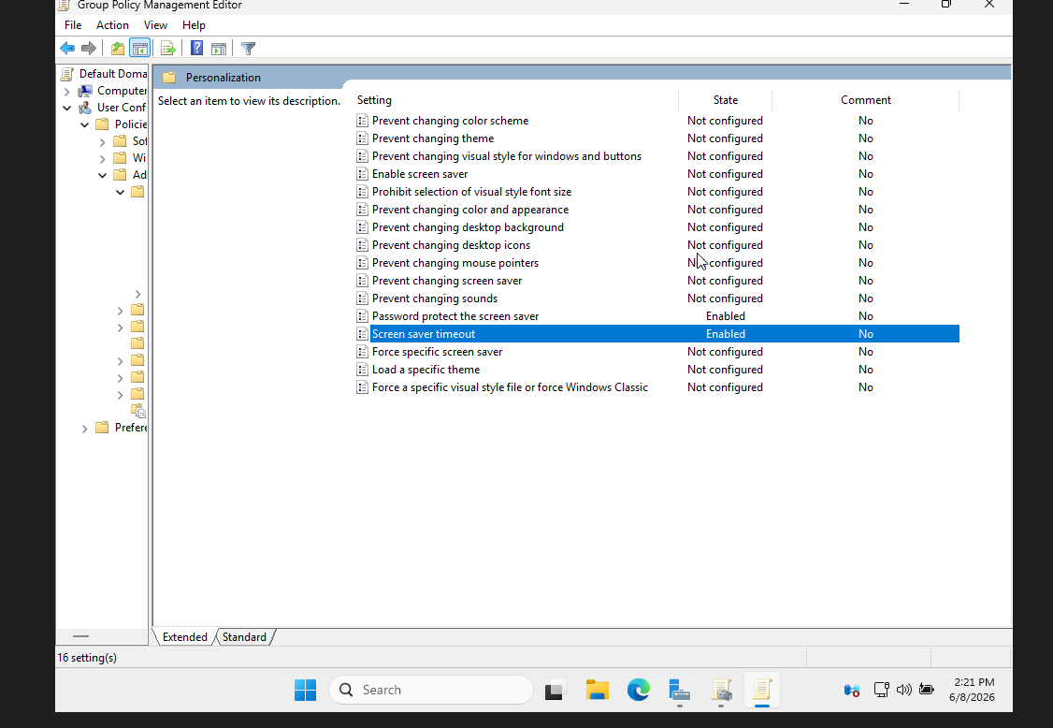

Lessons Learned
One of the biggest lessons from this project was understanding how many different services work together in a Windows environment. I gained experience with Active Directory, DNS, Organizational Units, security groups, permissions, and Group Policy. I also improved my troubleshooting skills while resolving issues during the Windows Server installation process.
Conclusion
This lab gave me practical experience with technologies commonly used in enterprise IT environments. By building and configuring an Active Directory environment from scratch, I developed a better understanding of user management, access control, and centralized security administration. The skills gained through this project will be valuable for future IT, system administration, and cybersecurity roles.

